Read the exam style question carefully, then fill in each section below.

Question:
A student wants to determine the volume of a sample of sodium hydroxide that reacts with 25 cm³ of 0.1 mol/dm³ sulfuric acid. The apparatus they can use is shown below.

- Describe a method that could be used to find the volume of sodium hydroxide that reacts with the sulfuric acid. (6)

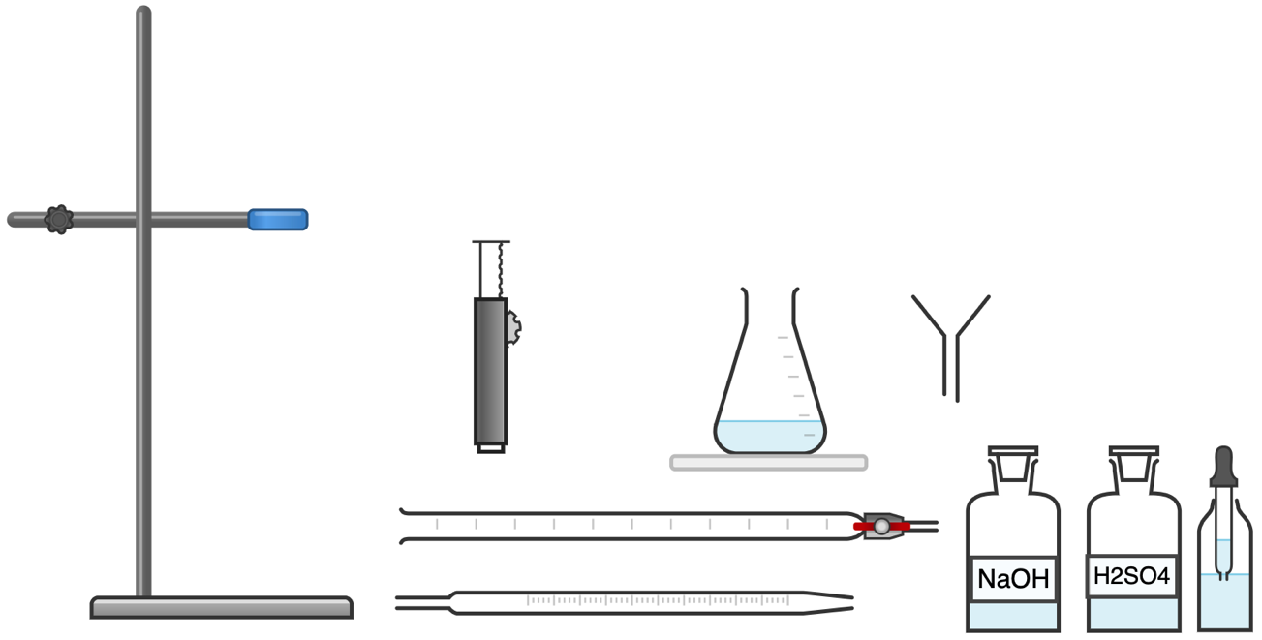
- Describe how they could use measurements to calculate the concentration of the sodium hydroxide. (3)

Section 1: At first glance
1. What command words are used in this question? Circle them clearly.
2. Underline the key information in the question above.
2. How many marks is this question worth?
Section 2: Thinking ahead
Read the question again.
What do you need to know in order to answer this question really well?
Can you split the question into two or more parts?
Are there any labelled diagrams that might help you to show your answer?
What are the key words that you should include in your answer?
Section 4: Space to plan
Use this space to plan your answer.

Section 4: Answer the question
________________________________________________________________________________________________________________________________________________________________________________________________________________________________________________________________________________________________________________________________________________________________________________________________________________________________________________________________________________________________________________________________________________________________________________________________________________________________________________________________________________________________________________________________________________________________________________________________________________________________________________________________________________________________________________________________________________________________________________________________________________________________________________________________________________________________________________________________________________________________________________________________________________________________________________________________

Section 5: Mark Scheme

Point | Mark
Fill burette with sodium hydroxide | 1
Use pipette to measure 25 cm³ of sulfuric acid | 1
Add a few drops of indicator (phenolphthalein) to the beaker/conical flask with acid | 1
Slowly add sodium hydroxide from burette to conical flask | 1
Swirl while adding/add sodium hydroxide drop wise | 1
Identify the end point of the reaction when the indicator changes colour | 1

Point | Mark
Use the concentration and volume of H₂SO₄ to calculate the number of moles of H₂SO4 that reacted  (n=cxv) | 1
Use the mole ratio from the balanced chemical equation to determine the number of moles of NaOH that reacted | 1
Calculate the concentration of NaOH using number of moles and measured volume  C= n/v | 1

